AWS S3 - Simple Storage Service

Cloud Storage - AWS S3

AWS S3 is also called AWS Simple Storage Service.

S3 is a storage service.

It allows uploading any type of file.

In S3 you can set access permissions to a file.

It is object-level storage.

It offers unlimited space in the storage.

The maximum file size is 5 TB.

What is Object-Level Storage?

Object-level storage contains objects.

Each object is made of:

* Data - any type of file
* Metadata - information about what the data is
* Key - unique identifier

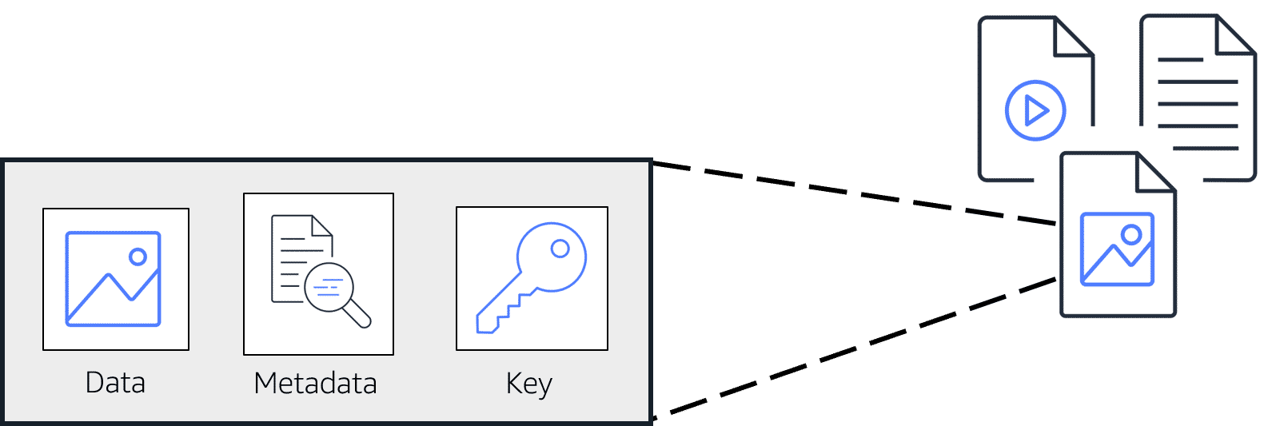

The picture illustrates object storage.

AWS S3 Storage Classes

There are many AWS S3 storage classes.

They differ in data availability.

How frequent data is retrieved and cost price.

S3 Standard

S3 Standard is ideal for data that is accessed often.

Provides high availability for stored objects.

It stores data in at least three Availability Zones.

It is the most expensive class.

S3 Standard-Infrequent Access

S3 Standard-Infrequent Access is also called S3 Standard-IA

S3 Standard-IA is ideal for data that is often accessed.

It has the same level of data availability as S3 Standard.

It stores data in at least three Availability Zones.

Lower storage price but higher data retrieval price.

It is higher priced than other classes.

S3 One Zone-IA (S3 One Zone-Infrequent Access)

It stores data in one Availability Zone.

It is cheaper than S3 Standard and S3 Standard-IA classes.

S3 Intelligent-Tiering

S3 Intelligent-Tiering requires automation and monitoring.

It is recommended for data with unknown or frequently changing access.

It moves the object to the S3 Standard-IA class if it is not accessed for 30 days.

It moves objects to S3 Standard if accessed in S3 Standard-IA or S3 One Zone-IA classes.

S3 Glacier

S3 Glacier is recommended for archiving data.

It can retrieve objects within a few minutes.

S3 Glacier is a cheaper and slower class.

S3 Glacier Deep Archive

S3 Glacier Deep Archive has the lowest cost.

Like S3 Glacier, it is best for archives.

Compared to S3 Glacier, S3 Glacier Deep Archive can retrieve objects within 12 hours.